Topcon Agriculture Support Bulletin

TAP Feed 6.0.1.284 release

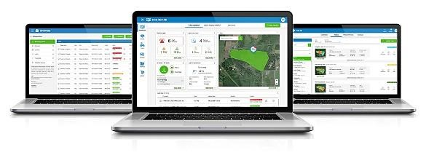

Description
New software version 6.0.1.284 will be released on the 23rd of November 2021 to the Topcon Agriculture Platform (TAP) Feed.

This software release contains Improvements and Resolved Issues that have been escalated to Topcon Engineering.

The next time you log in to TAP Feed, you will have the below instalments.

Resolved issues and Improvements
- The logic to process data from the FEED App has been improved to prevent loads to be combined.
- The [NEW PREMIX] button with edit recipe works.
- A user with unit system 'imperial' selected, the default density for a new recipe or premix now is 350 kg/m3 instead of 21,85 kg/m3.
- When the required property 'dryMatterPerc' for ingredients is missing in the payload from the FEED App, the data will be processed now.
- When an ingredient, recipe, premix, pen, mixer, or operator is deleted and data is still to be processed using USB data transfer, this data is processed correct now.
- The scale weight unit is applied correct now when FEED App data import wizard is executed

